Name: Pranali Sonawane
Subject: CCNA
Date: 18-11-2025
Lab – OSPF Configuration(Load Balancing) :
First, take two routers (e.g., 1841), two switches, and four PCs. Connect the routers, switches, and PCs using straight-through cables. Also, connect the serial interfaces using a straight-through cable and connect the FastEthernet interfaces using crossover cables
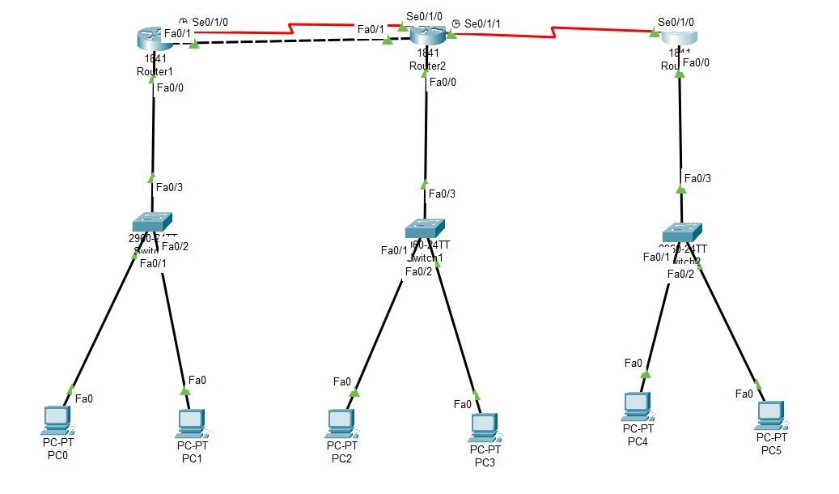
Configure PCs :
- PC0:
  - IPv4 Address: 10.0.0.2
  - Subnet Mask: 255.0.0.0
  - Default Gateway: 10.0.0.1
- PC1:
  - IPv4 Address: 10.0.0.3
  - Subnet Mask: 255.0.0.0
  - Default Gateway: 10.0.0.1
- PC2:
  - IPv4 Address: 20.0.0.2
  - Subnet Mask: 255.0.0.0
  - Default Gateway: 20.0.0.1
- PC3:
  - IPv4 Address: 20.0.0.3
  - Subnet Mask: 255.0.0.0
  - Default Gateway: 20.0.0.1
- PC4:
  - IPv4 Address: 30.0.0.2
  - Subnet Mask: 255.0.0.0
  - Default Gateway: 30.0.0.1
- PC5:
  - IPv4 Address: 30.0.0.3
  - Subnet Mask: 255.0.0.0
  - Default Gateway: 30.0.0.1

Open Router 1 – CLI prompt then type following commands
Router>enable
Router#configure terminal
Router(config)# interface fastEthernet 0/0
Router(config-if)# ip address 10.0.0.1 255.0.0.0
Router(config-if)#no shutdown
Router(config-if)#exit

Router(config)#interface serial 0/1/0
Router(config-if)#ip address 40.0.0.1 255.0.0.0
Router(config-if)#no shutdown
Router(config-if)#exit

Router(config)# interface fastEthernet 0/0
Router(config-if)# ip address 60.0.0.1 255.0.0.0
Router(config-if)#no shutdown
Router(config-if)#exit

Router(config)#router ospf 1
Router(config-router)#network 10.0.0.0 0.255.255.255 area 0
Router(config-router)#network 60.0.0.0 0.255.255.255 area 0
Router(config-router)#network 40.0.0.0 0.255.255.255 area 0
Router(config-router)#exit
Router(config)#exit
Router#show ip route
Router#show ip os nei

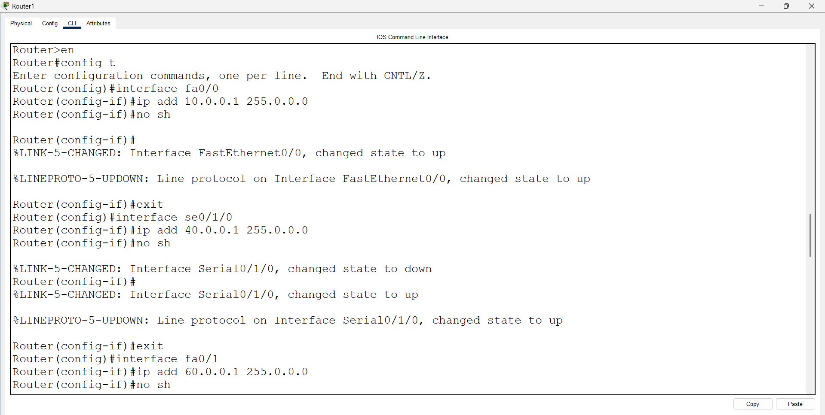
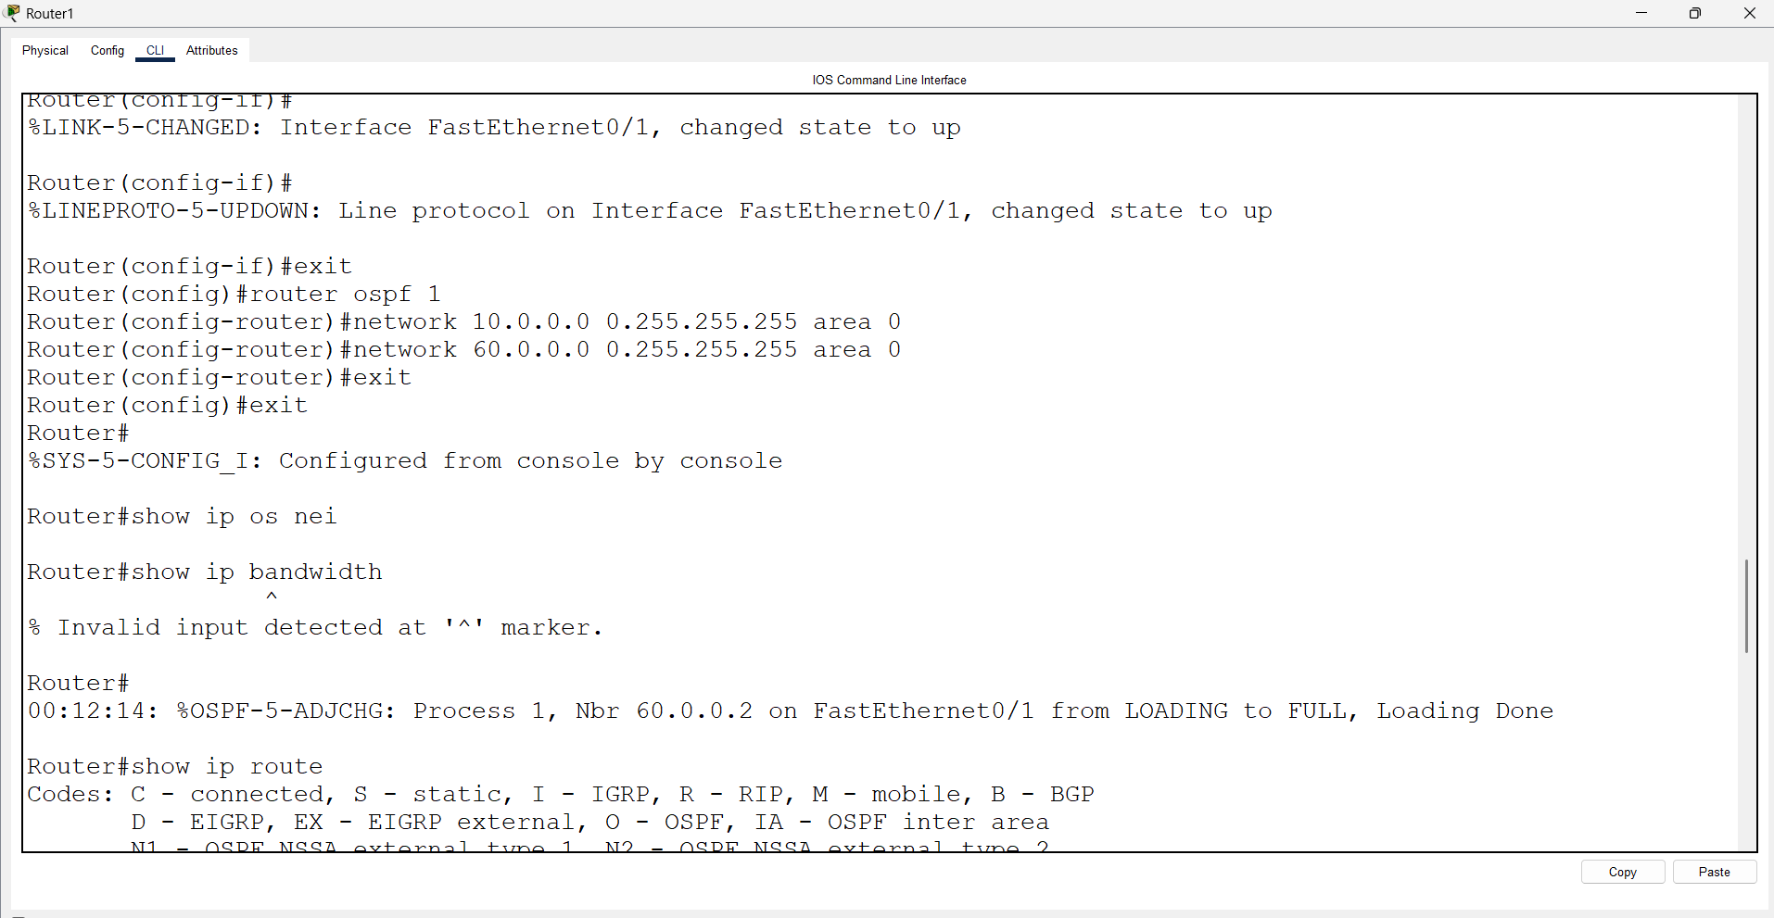
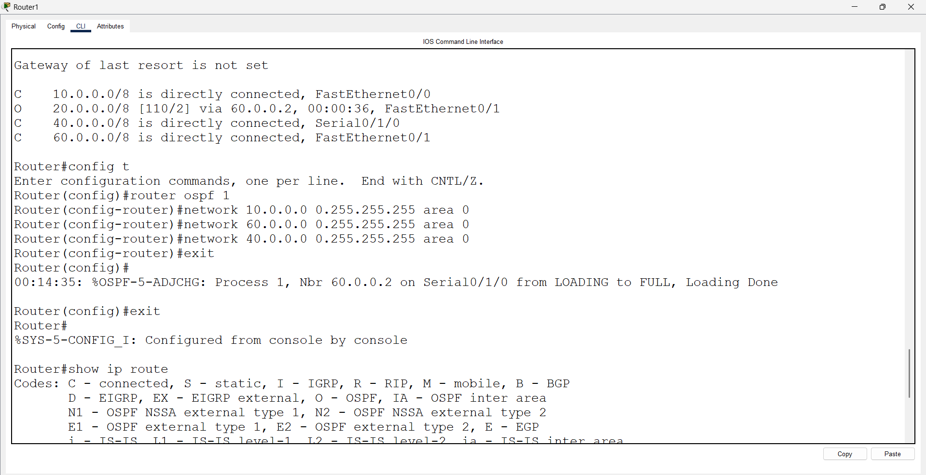
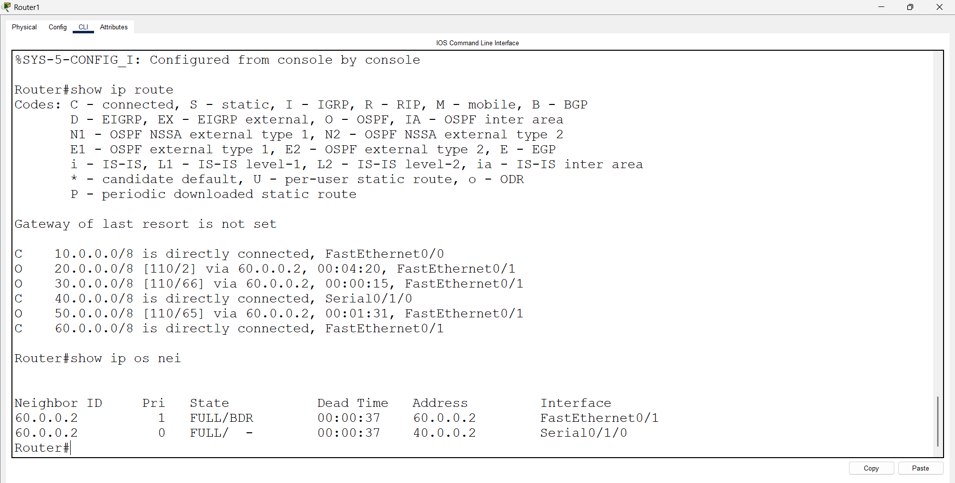
Open Router 2 – CLI prompt then type following commands
Router>enable
Router#configure terminal
Router(config)# interface fastEthernet 0/0
Router(config-if)# ip address 20.0.0.1 255.0.0.0
Router(config-if)#no shutdown
Router(config-if)#exit

Router(config)#interface serial 0/1/0
Router(config-if)#ip address 40.0.0.2 255.0.0.0
Router(config-if)#no shutdown
Router(config-if)#exit

Router(config)# interface fastEthernet 0/1
Router(config-if)# ip address 60.0.0.2 255.0.0.0
Router(config-if)#no shutdown
Router(config-if)#exit

Router(config)#interface serial 0/1/1
Router(config-if)#ip address 50.0.0.1 255.0.0.0
Router(config-if)#no shutdown
Router(config-if)#exit

Router(config)#router ospf 1
Router(config-router)#network 20.0.0.0 0.255.255.255 area 0
Router(config-router)#network 40.0.0.0 0.255.255.255 area 0
Router(config-router)#network 50.0.0.0 0.255.255.255 area 0
Router(config-router)#network 60.0.0.0 0.255.255.255 area 0
Router(config-router)#exit
Router(config)#exit
Router#show ip route
Router#show ip os nei

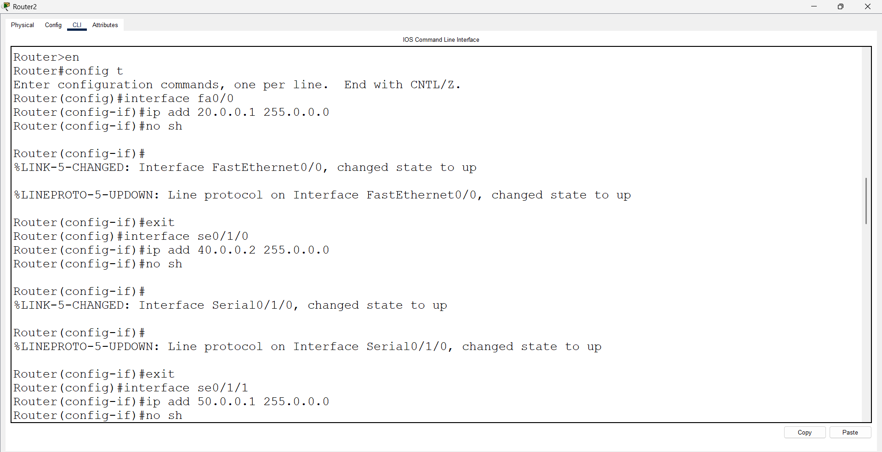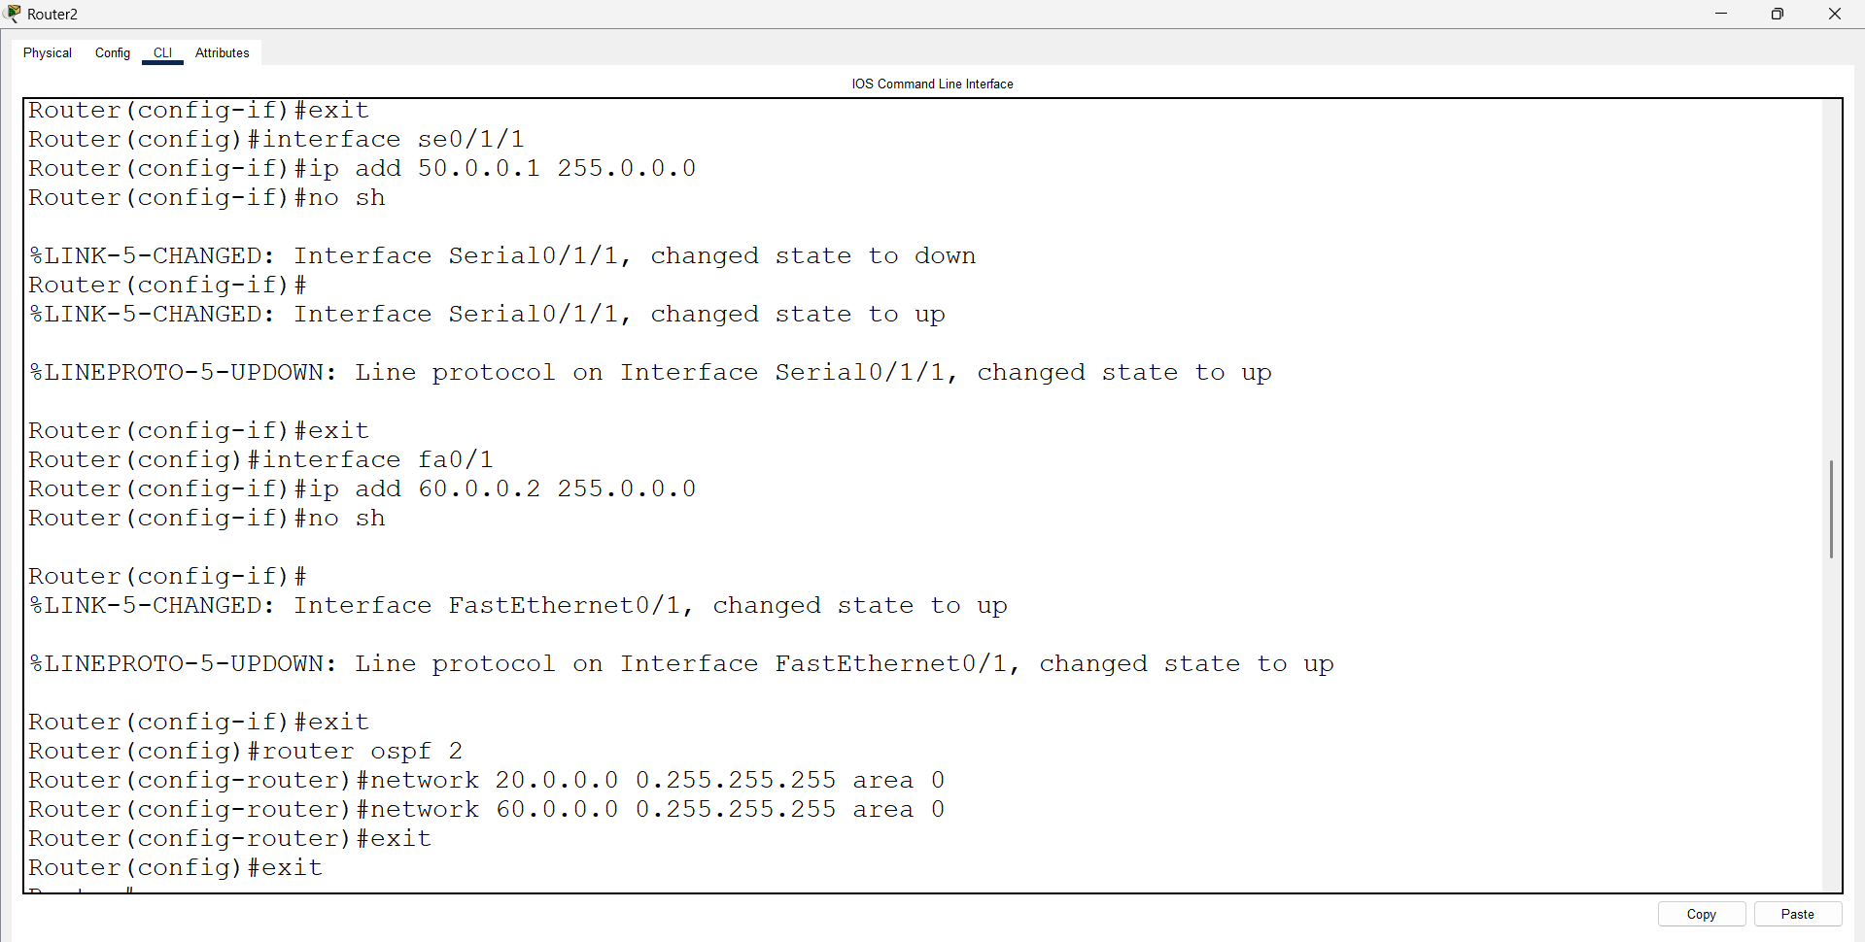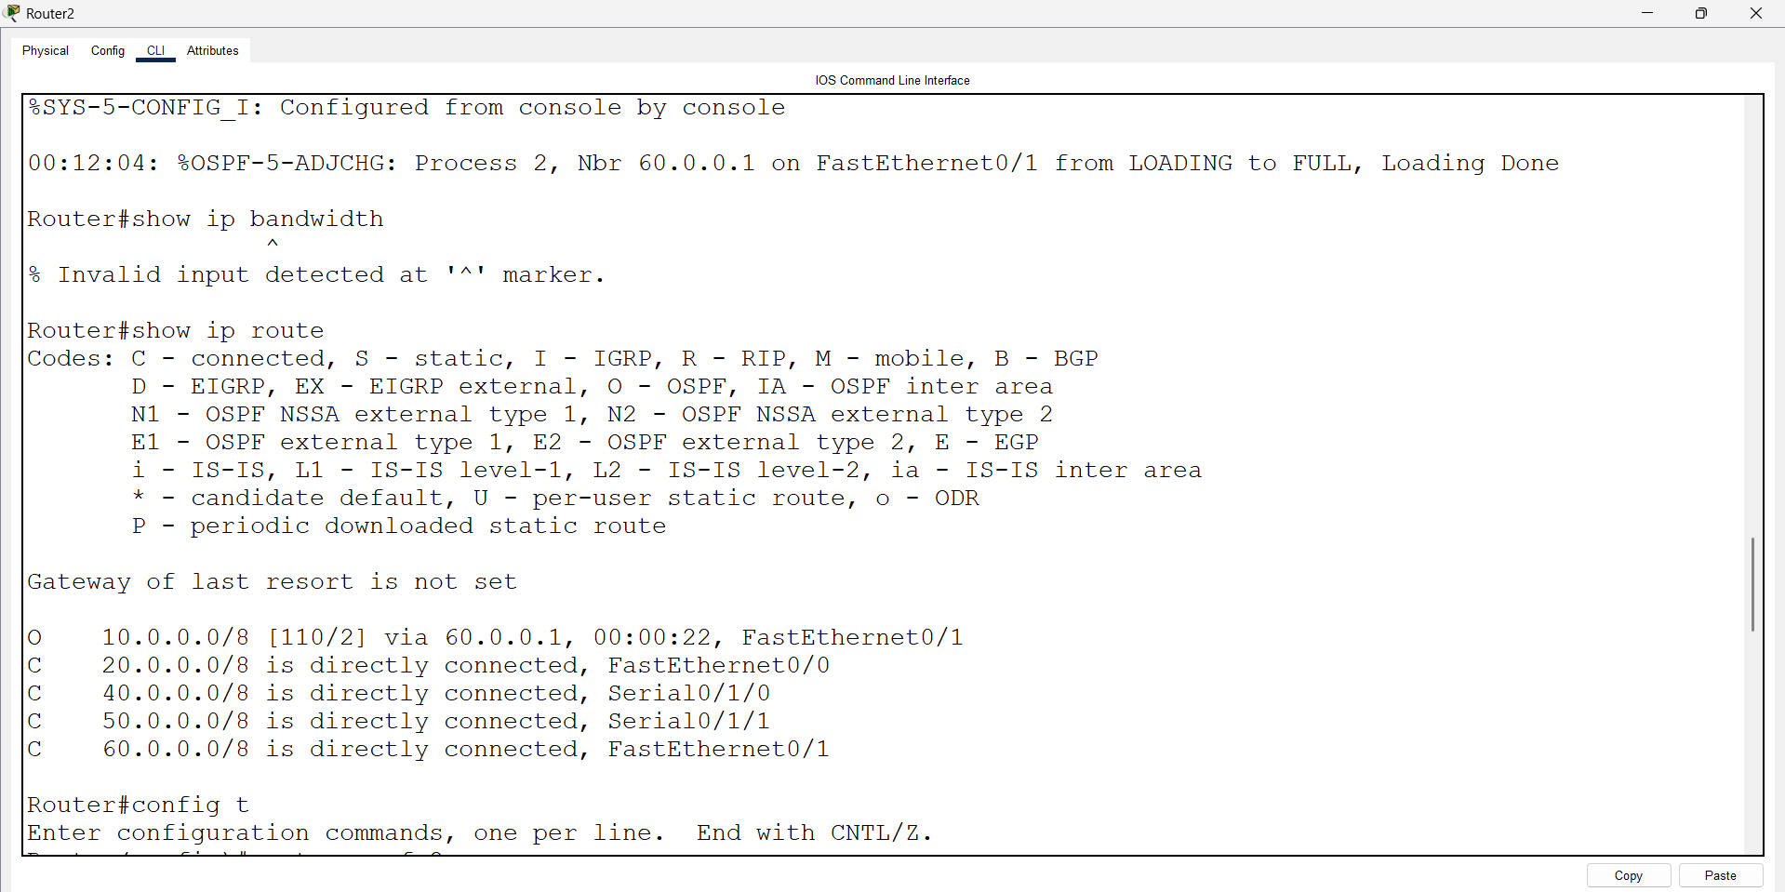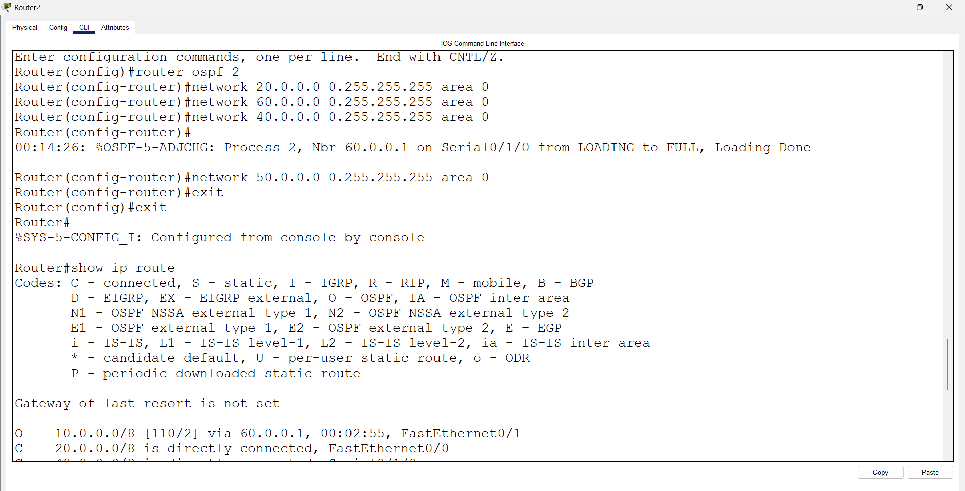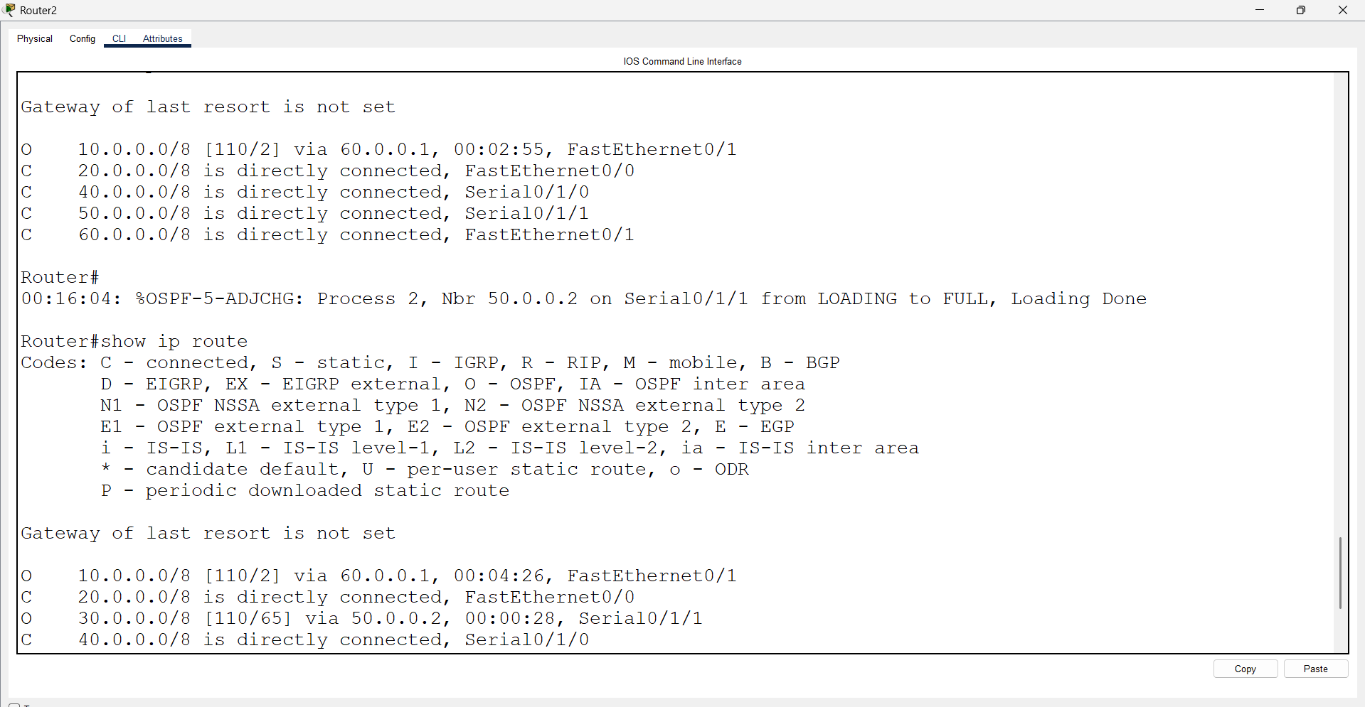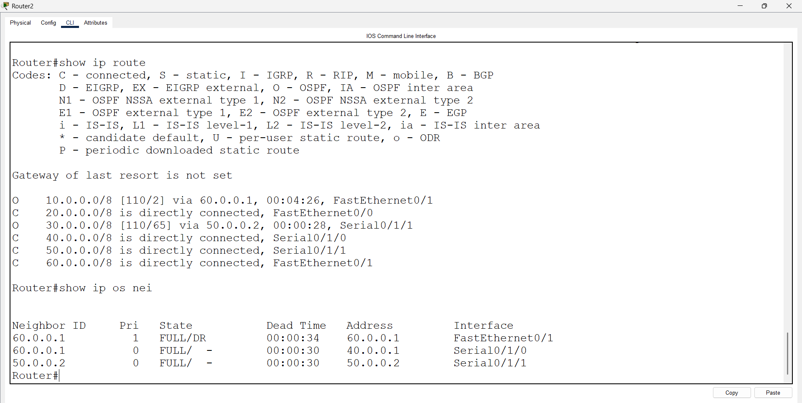
Open Router 3 – CLI prompt then type following commands
Router>enable
Router#configure terminal
Router(config)# interface fastEthernet 0/0
Router(config-if)# ip address 30.0.0.1 255.0.0.0
Router(config-if)#no shutdown
Router(config-if)#exit

Router(config)#interface serial 0/1/0
Router(config-if)#ip address 50.0.0.2 255.0.0.0
Router(config-if)#no shutdown
Router(config-if)#exit

Router(config)#router ospf 1
Router(config-router)#network 30.0.0.0 0.255.255.255 area 0
Router(config-router)#network 50.0.0.0 0.255.255.255 area 0
Router(config-router)#exit
Router(config)#exit
Router#show ip route
Router#show ip os nei

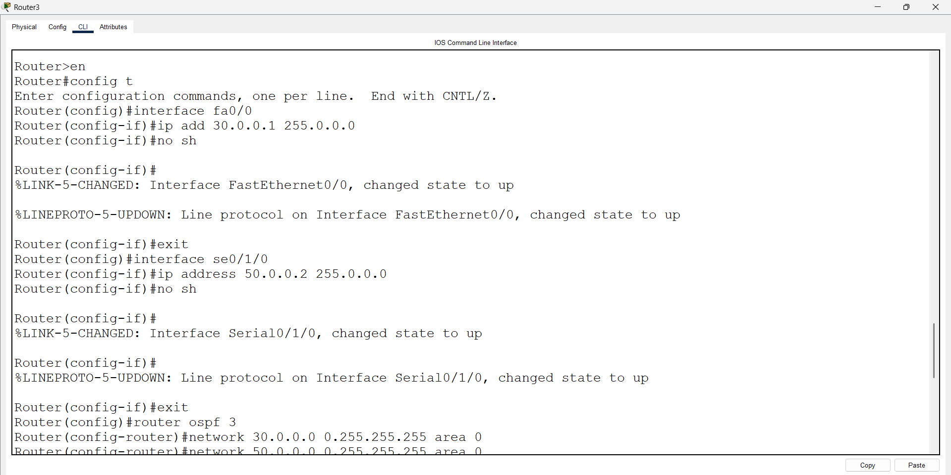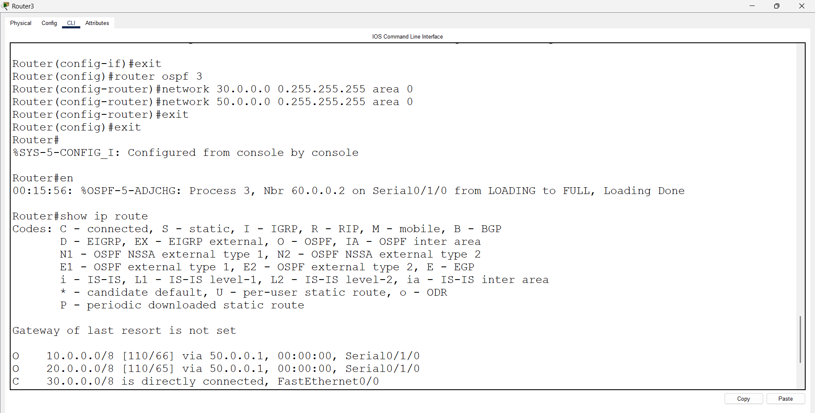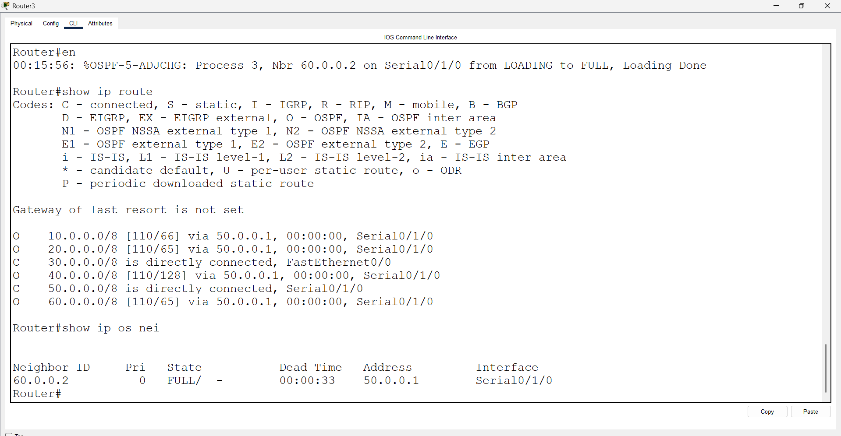
Load Balancing :
Open Router 1 – CLI prompt then type following commands
Router>enable
Router#configure terminal
Router(config)# interface se0/1/0
Router(config-if)# ip ospf cost 1
Router(config-if)#exit
Router(config)#exit
Router# show ip route

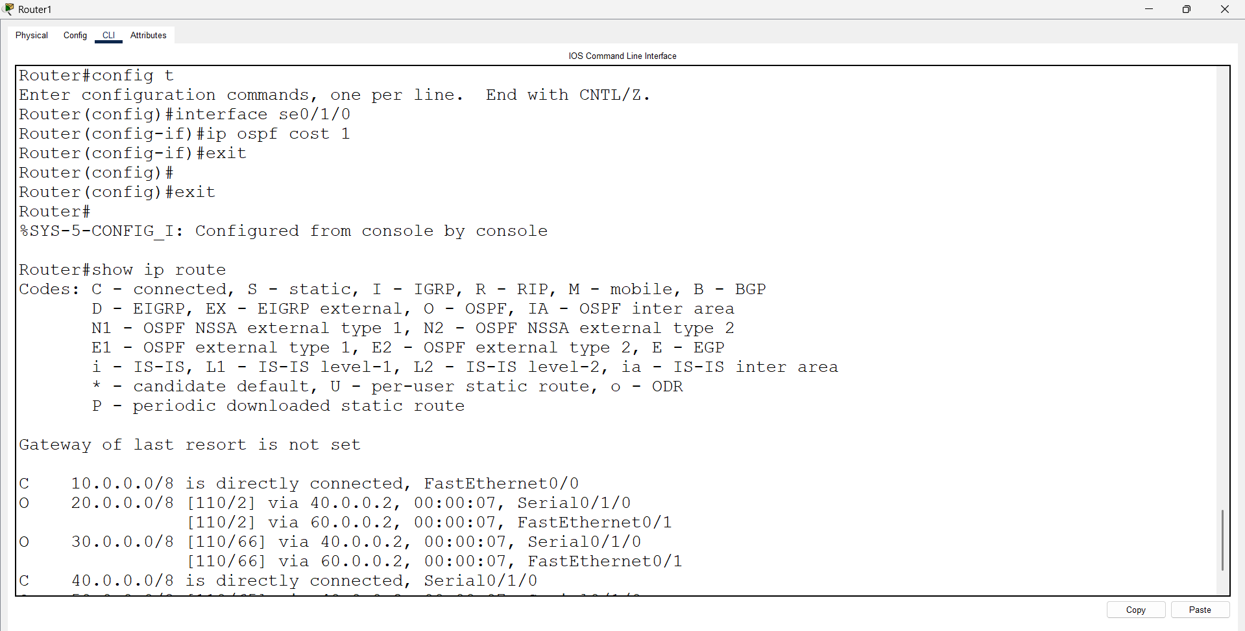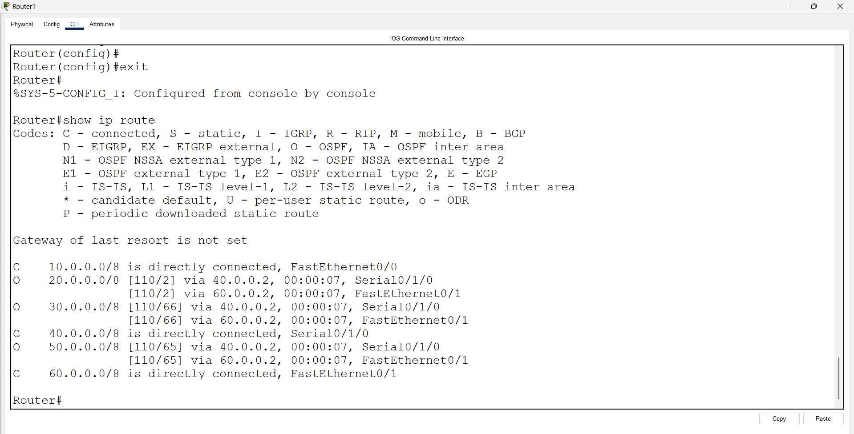
Open Router 2 – CLI prompt then type following commands
Router>enable
Router#configure terminal
Router(config)# interface se0/1/0
Router(config-if)# ip ospf cost 1
Router(config-if)#exit
Router(config)#exit
Router# show ip route

